**Unit Three: Exploring Holidays Around the World**

**Lesson 11: Eid El-Fitr and Eid El-Adha**

Name: __________________________________ Date: _______________________

1. **Label each sentence as a fact or an opinion.**
2. Families’ gathering is a traditional way to celebrate Eid El-Fitr and Eid El Adha. _____________
3. While celebrating, people have a marvelous time. _________________
4. During Eid El-Fitr and Eid El Adha, people think of the poor families and send them clothes and food. _________________
5. People believe that when they pray, they show respect for God. _________________
6. The best part for children is visiting their relatives and eating their favorite sweets. ____________
7. Everyone likes to wear new clothes. _________________
8. **Fill in the following web with a list of things you like to do when you celebrate with your family.**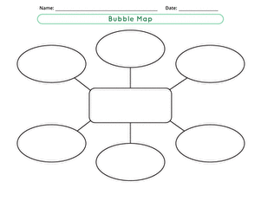



1. **Now, use the ideas you listed in the above exercise to write a short paragraph about the things you do when you celebrate with your family. Describe your feelings on that occasion as well.**

**_____________________________________________________________________________________________________________________________________________________________________________________________________________________________________________________________________________________________________________________________________________________________________________________________________________________________________________________________________________________________________**

Name: __________________________________ Date: _______________________

**A Day to Share the Joy**

The sounds in the town park got louder and louder, fireworks in the shape of mountains and cedar trees with their amazing colors glittered in the sky. The children took turns lighting all the fireworks before it was time for the big dinner.

Zahi was still watching in surprise. He wondered what those lights beneath him were; different shapes, different colors! “There must be something wrong," he said to himself. "I have to know what that is! It's not the first time I see such things coming up from Planet Earth!"

I can hear people on Earth! Let me find out if I can chat with someone on the internet!" Zahi thought. "There, I’ve got through!" Zahi exclaimed.

He read, 1 am Zena from Lebanon. Who are you?

Zahi quickly typed, 1 am Zahi, a boy from Planet Orecon. I'd like to have a friend from Earth. Tell me what's happening on Earth now!" Zena couldn’t believe her eyes.

Dad helped Zena chat with Zahi. "It's an occasion for family gatherings.”

Mom added, “We always think of the needy at this time. We donate what we can: money, food and clothing. We also pray that God keeps us safe and sound.”

Zena said, “Eid, is a time for caring and sharing with everyone around us. We always wear new clothes and have delicious foods. We try to do our best to keep our Earth a place for love and peace.

“But I still don't understand what all these glittering lights are for!" Zahi exclaimed.

"These are fireworks that make a loud noise or beautiful fiery display at night. We usually light them to express our joy during the Eid", Zena answered.

"They look wonderful from Orecon! How many times do you celebrate Eid?"

"Twice a year, after we fast during the month of Ramadan and then for Adha.

Zahi was astonished at what he learned. “I wish I could share your joys," he wrote.

Name: __________________________________ Date: _______________________

1. **People in Planet Orecon do not celebrate as people on Earth. Answer the following questions to show what Zahi learned from Zena.**
2. When do people on Earth celebrate the Eid?

____________________________________________________________________________________________________________________________________________________________

1. Who takes part in the celebration?

____________________________________________________________________________________________________________________________________________________________

1. Where do they celebrate the Eid?

____________________________________________________________________________________________________________________________________________________________

1. What do they do during this occasion?

____________________________________________________________________________________________________________________________________________________________

1. How do people feel during the Eid?

____________________________________________________________________________________________________________________________________________________________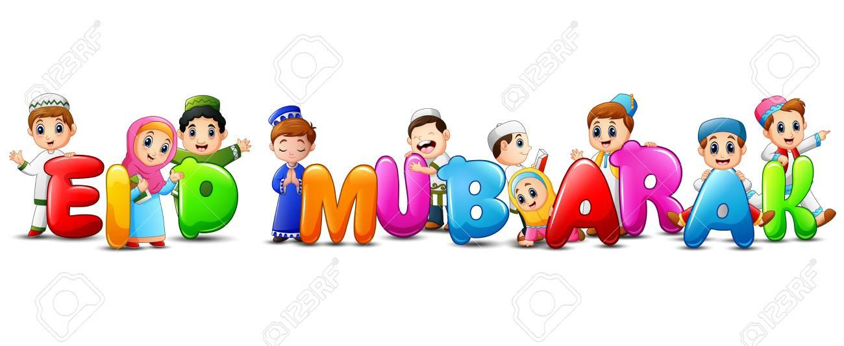

Name: __________________________________ Date: _______________________

1. **Solve the following riddles. All words start with ‘dis’.**
2. I cannot connect to the WIFI, I got _____________________________
3. Wissam is not able to walk. He is _____________________________
4. The file doesn’t appear on the screen, it _____________________________
5. Sana is not pleased by her new hair style, she is _____________________________
6. **Choose the answer that best completes each sentence.**
7. I don’t like watermelon,
8. I dislike it.
9. I displease it.
10. Ali and Jana don’t agree on where to travel,
11. they dislike it.
12. they disagree.
13. Rami knew something new about Mars Planet,
14. he disclosed new information.
15. he discovered new information.
16. I went to the shop to buy new clothes because
17. they had discounts on all items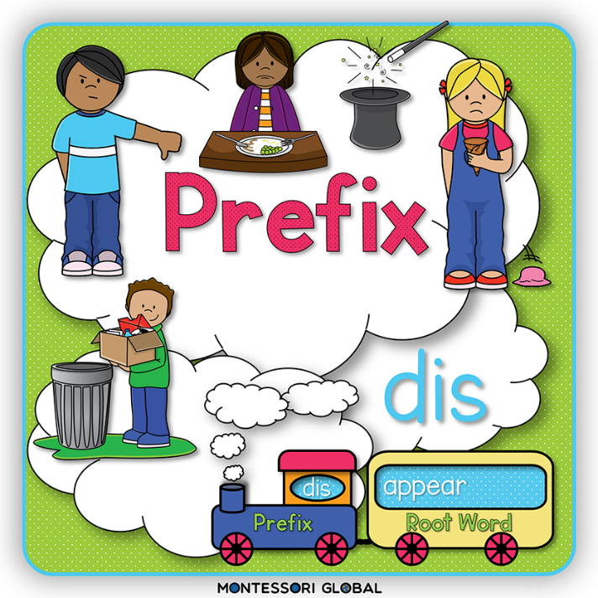
18. they disconnected to all items.

Name: __________________________________ Date: _______________________

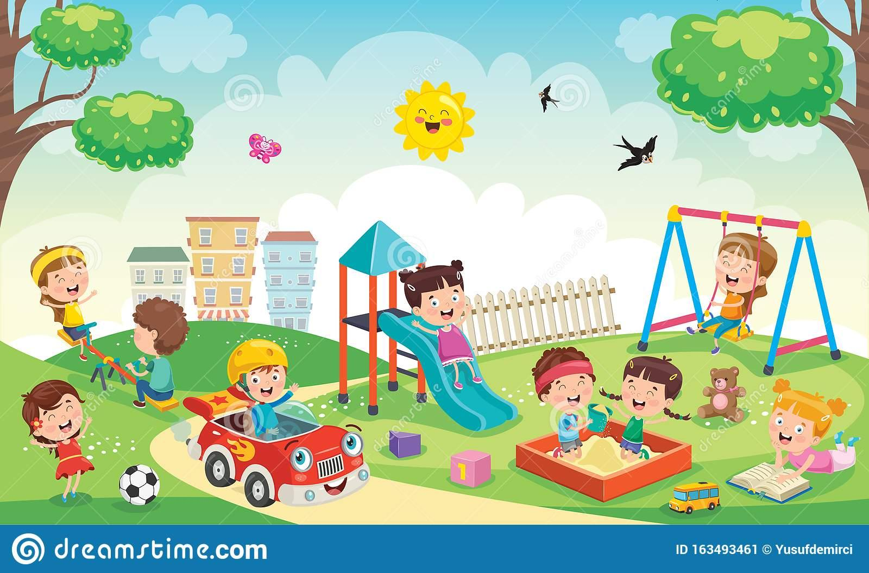

1. **Look at the picture, then fill in the following chart with things you see. You can name the children as you like.**

| **people** | **animals** | **places** | **things** |
| --- | --- | --- | --- |
|  |  |  |  |
|  |  |  |  |

1. **Use the nouns you added in the above exercise to write a short paragraph describing the picture. Don’t forget to capitalize all proper nouns.**

____________________________________________________________________________________________________________________________________________________________________________________________________________________________________________________________________________________________________________________________________________________________________________________________________________________________________________________________________________________

Name: __________________________________ Date: _______________________

**Abraham**

Abraham

Who lived a

Long time ago was

a faithful and obedient man.

Once Abraham thought that God

spoke to him, "Sacrifice your son,"

was what Abraham heard. So, he took

his son to the mountain top and prepared

to carry out what had been said. At that moment

a sheep was sent by God. Take this. Sacrifice the

sheep instead." Now people celebrate the Adha to show

their love, faithfulness and obedience

to God

1. **Referring to the above poem, sequence the following ideas. Write first, next, then, later, and last on the provided spaces.**

________________ Abraham took his son to the mountain top.

________________ When he wanted to sacrifice his son, God sent him a sheep instead

________________People celebrate the Adha to show their obedience to God.

________________ He thought that God spoke to him.

________________ Abraham was a faithful man.

1. **Now, write the above sentences in order to form a paragraph that retells the poem.**

________________________________________________________________________________________________________________________________________________________________________________________________________________________________________________________________________________________________________________________________________________________________________________________________________________________________________________________________________________________________

Name: __________________________________ Date: _______________________

1. **Draw a picture of a person, animal, place or thing in the box. Then, complete the phrases with the required words.**
2. The thing you drew is a __________________________
3. Describe it in two words. _____________/___________
4. Write three actions (verbs) that what you drew expresses

________________/________________/______________

1. Mention four feelings about what you drew

____________/_____________/___________/____________

1. Write one word that is a synonym to what you mentioned in

number 1, or give it a different name. _______________

1. **Now, write a cinquain using the ideas you filled above. A cinquain is a kind of poem that is made up of 5 lines only, on each we have a number of words only. Cinquains may rhyme or may not.**

___________________

___________________,___________________

___________________,___________________,___________________

___________________,___________________,___________________,___________________

___________________

